Temă laborator 3

1.

a) Adresa IP: v4: IPv4 Address. : 192.168.0.106(Preferred)

v6: Link-local IPv6 Address fe80::6c14:e07a:4a15:e02d%14(Preferred)

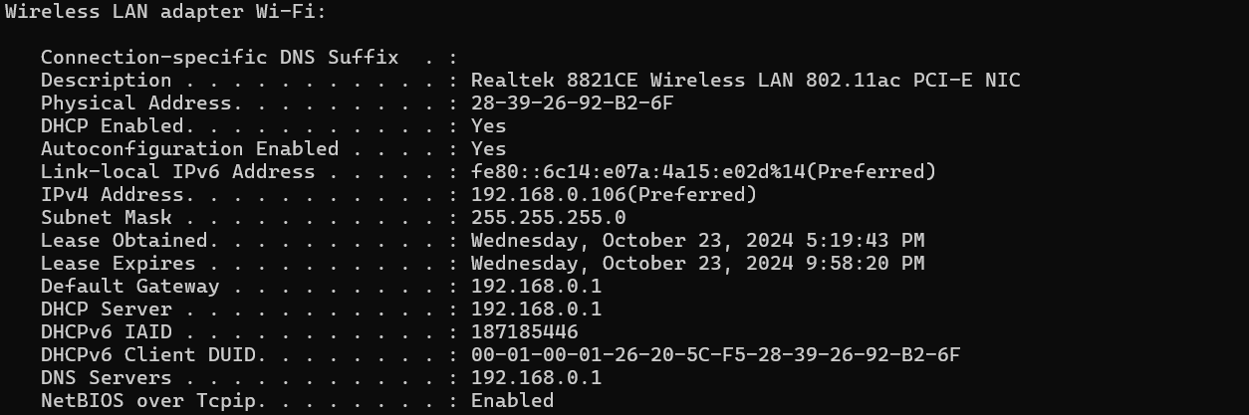

b) Adresa MAC: 28-39-26-92-B2-6F

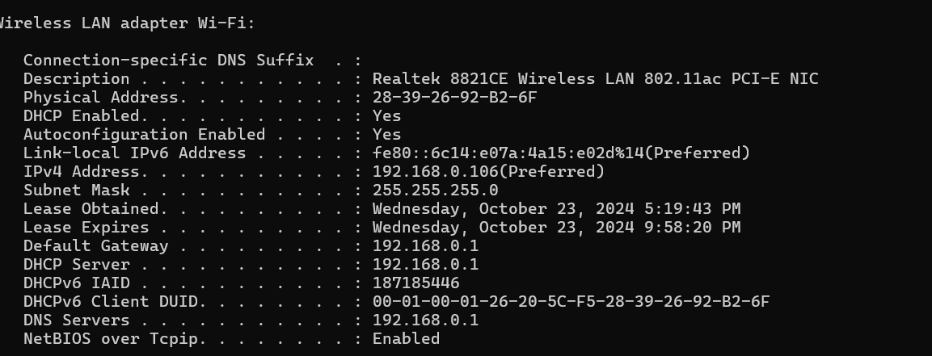

c)Tipuri de interfețe: Description: Bluetooth Device (Personal Area Network)

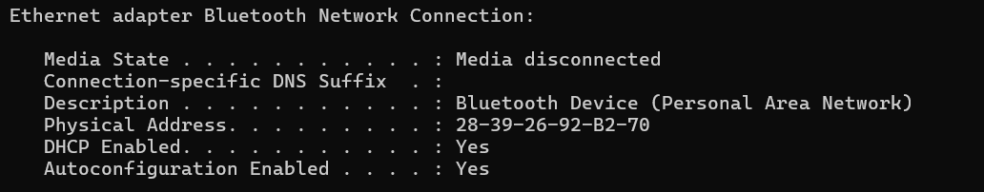

d) Numărul de pachete transmise:

Packets: Sent=4; Received=4; Lost= 0 (0% loss)

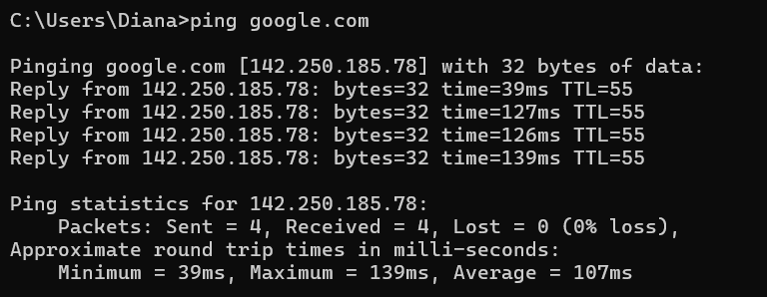

e) Exemplificari de rute de conectivitate : [142.250.185.78] cu 32 bytes de date

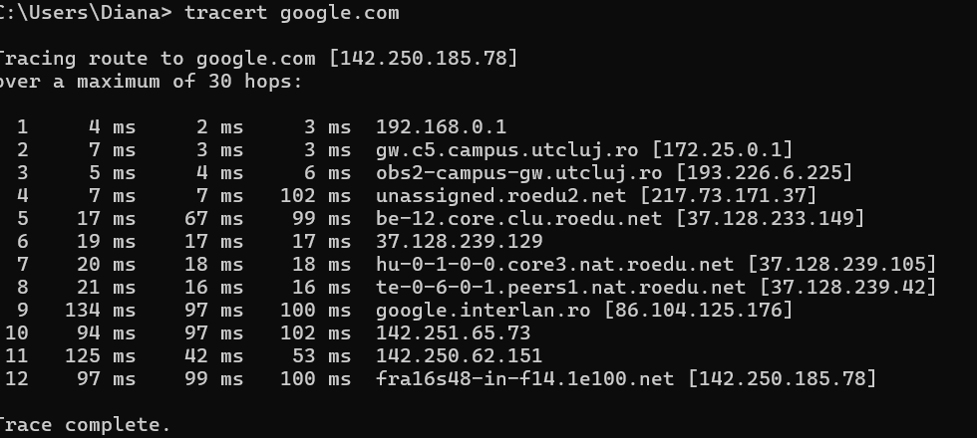

2.

a)Procese:

Adobe Acrobat Update Service

Application Frame Host

AvastAntivirus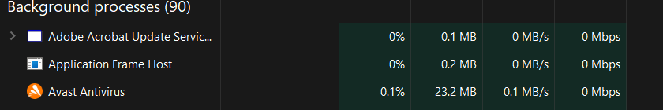

b) Servicii

Service Host: AVCTP service

Service Host: Background Intelligent

Service Host: Application Management

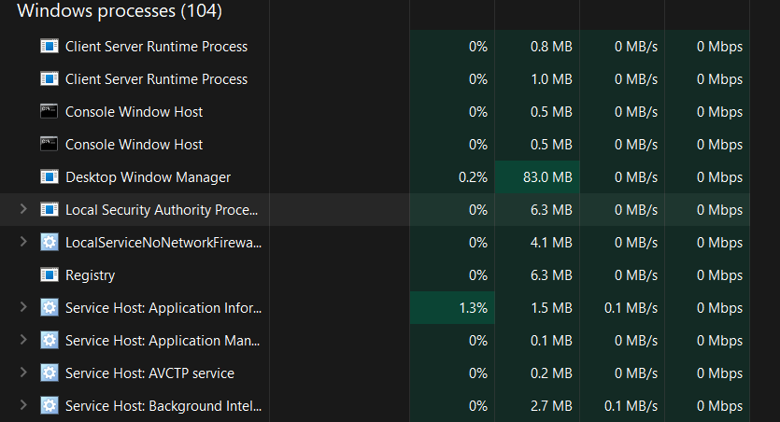

c) Aplicatii

Microsoft Teams

Google Chrome

Microsoft Word

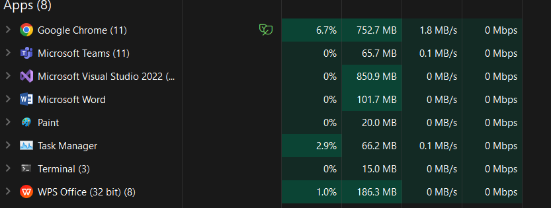

d) CPU

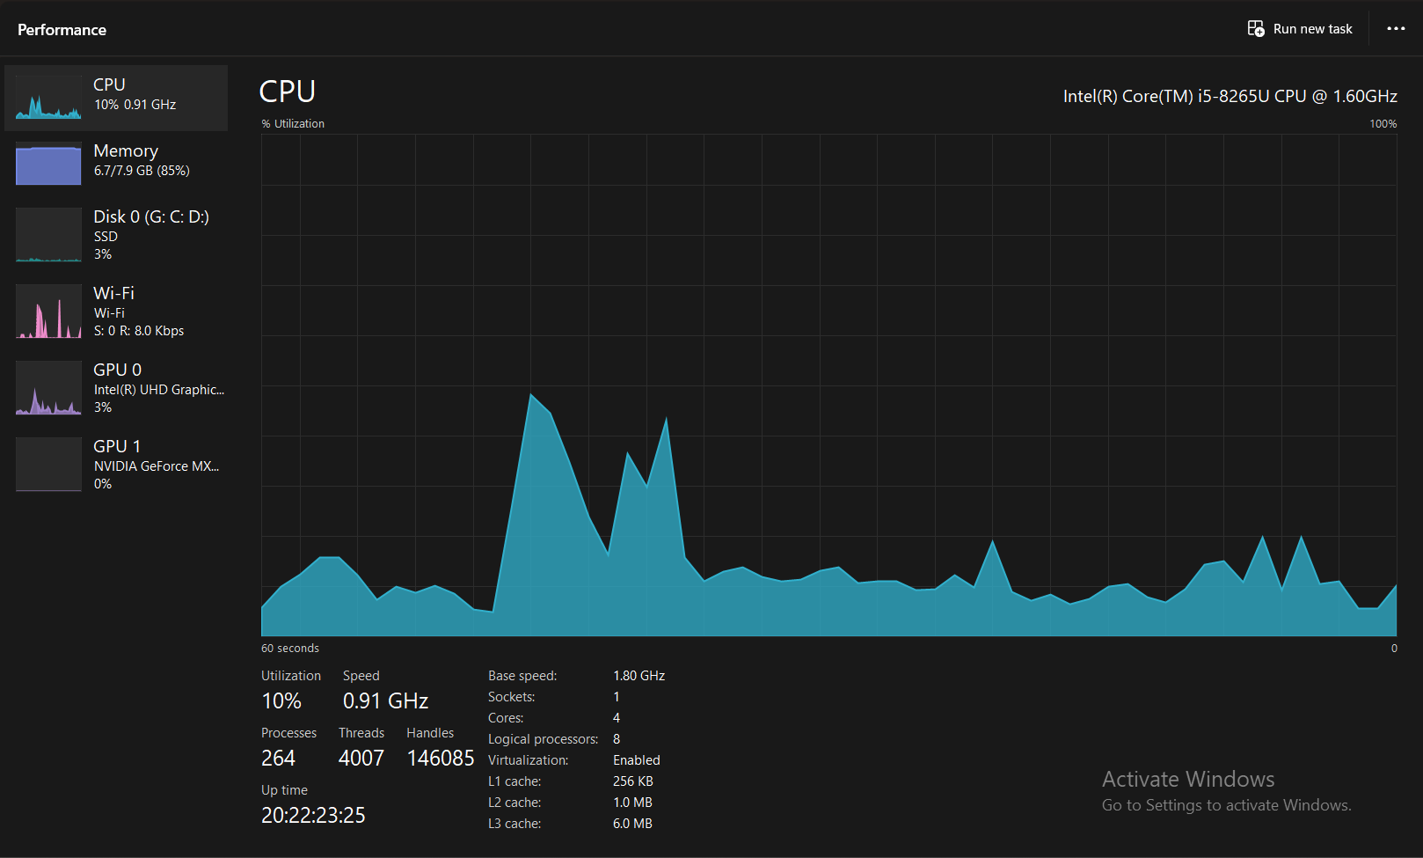

e)

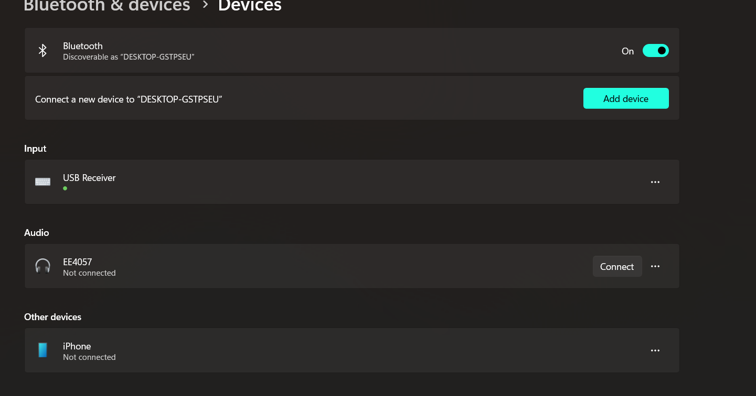

3.

a)

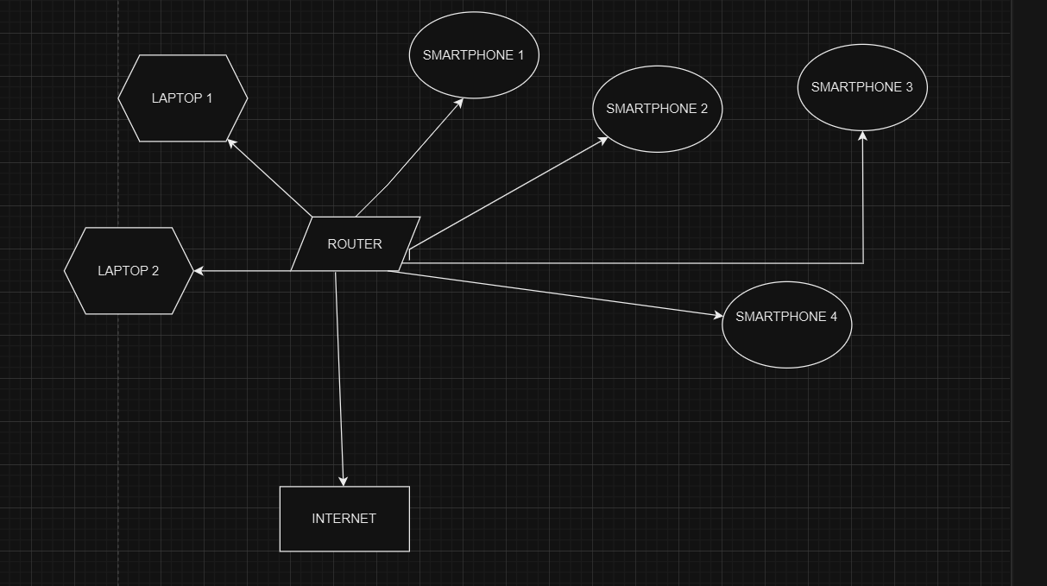

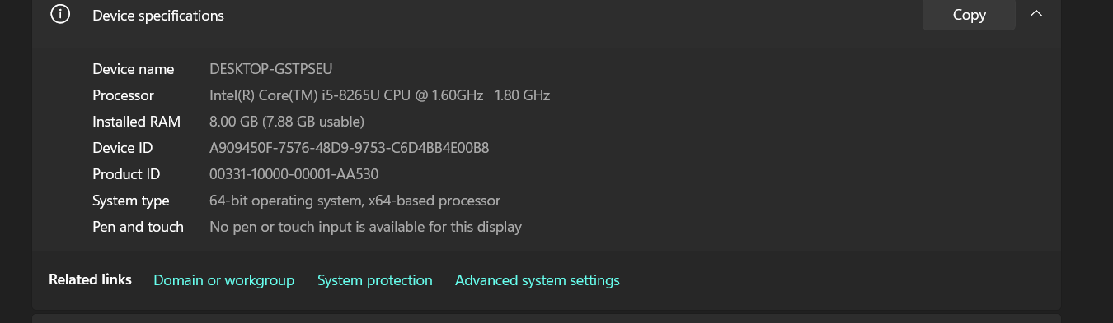

b)

IPv4 address: 192.168.0.106

IPv4 DNS servers: 192.168.0.1

Physical address (MAC): 2A-39-26-12-09-04

c)

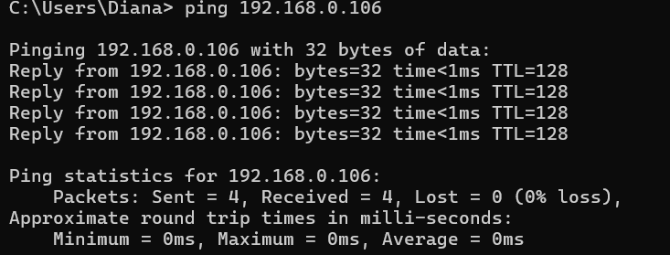

d) WAN

4.1.

1600x1200x8=15360000

56kbs=274s

1mbps= 15.36s

10mbps= 1.536s

100mbps= 0.153s

4.2

Avem 4 linii de viteze si 10 linii diferite

100ms x 1048576=104857600 ms